**ECNS 560 Term Project: Bison Population**

**Kyle Froisland and Saki**

**Topic:** American Buffalo (Bison) Population Levels from Early 2000’s to Now

**Potential Research Questions:**

1. How much has Bison population changed in the US compared to Canada?
2. How much has Bison population changed in different parts of the US?
3. How does Bison health vary across habitats/ranges?
4. Do variations in state/national park laws and regulations impact Bison population levels?
   1. Examples: availability of hunting tags, zoning/homesteading or prevalence of private ranches under/over a certain size, regulations on meat/pelt sales (would need to locate data for specific “X” ideas)
5. Do variations in state/national park laws and regulations impact average Bison weight?
6. How does weather/geography impact population health? (would need to find data for this if interested in pursuing)

**Motivation:** Bison population reached near extinction (estimates generally say a few hundred bison) during the late 19th century, but had a miraculous comeback in the early to middle 20th century. However, the health and sustainability of bison populations is still an issue. Factors such as the opportunity cost of agricultural farming and cattle ranching loom and tend to crowd out bison domestication, and policies such as homesteading and urban expansion encroach on the grazing land of bison. Bison, being the national mammal of the U.S., play a culturally significant part in the history of the United States as well as the culture of native populations prior to the establishment of the United States. Thus, conservation efforts, regulations, or subsidies/incentives for private herds and domestication may be worth consideration by policy makers or conservation groups.

**Data:**

1. Bison population numbers by county from ArcGIS, Center of Excellence for Bison Studies, South Dakota State: [Bison by the Numbers (arcgis.com)](https://storymaps.arcgis.com/stories/6cc9ee1b777447128d811238babfe1ed)
   1. Years covered: 2002, 2007, 2012, 2017
   2. Variables: State, County, Population (by year), Number of Operations (by year)
      1. Note: data not in tidy format, but can join by region or year once we pivot
2. Wood Buffalo National Park, Canada Bison population from Canadian Government Open Data: [Bison abundance - Wood Buffalo National Park - Open Government Portal (canada.ca)](https://open.canada.ca/data/en/dataset/1947229a-be15-4b10-bfdb-b2f0fc5f39e6)
   1. Years Covered: 2002 – 2016
   2. Variables: Location, Date, Population
   3. Note: lacks good identification of years past 2009
3. United States Geological Survey (USGS) Bison Range and Bison Habitat Maps: [American Bison (Bison bison) mBISOx_CONUS_2001v1 Range Map - ScienceBase-Catalog](https://www.sciencebase.gov/catalog/item/59f5ec59e4b063d5d307e657) and [American Bison (Bison bison) mBISOx_CONUS_2001v1 Habitat Map - ScienceBase-Catalog](https://www.sciencebase.gov/catalog/item/58fa620be4b0b7ea54525758)
   1. Provides spatial data on ranges and habitats

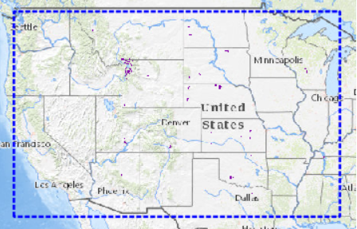

1. Bison Body Mass Data for Select Regions, 2019: [Dryad | Data -- Bison body size and climate change (datadryad.org)](https://datadryad.org/stash/dataset/doi:10.5061/dryad.hp38ct1#:~:text=Bison%20are%20well-represented%20in%20the%20fossil%20record%20across%20North)
   1. Variables of interest: Locality/Area, Weight (as a potential proxy for health)